ASSIGNMENT - 20
Task 1 – Input Validation Check
Task:
Analyze an AI-generated Python login script for input validation
vulnerabilities.
Instructions:
• Prompt AI to generate a simple username-password login
program.
• Review whether input sanitization and validation are
implemented.
• Suggest secure improvements (e.g., using re for input validation).
Expected Output:
• A secure version of the login script with proper input validation
Prompt:Give an Python code for this questions and Should print the Output with out any Errors.
Code and Output:
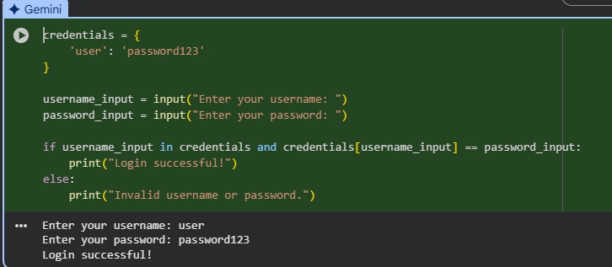
Observation:
In this code we can Observe that the code is generated by the AI with out any errors and Code consists of credentials function if username and password is correct then it will print

Task 2 – SQL Injection Prevention
Task:
Test an AI-generated script that performs SQL queries on a database.
Instructions:
• Ask AI to generate a Python script using SQLite/MySQL to fetch
user details.
• Identify if the code is vulnerable to SQL injection (e.g., using
string concatenation in queries).
• Refactor using parameterized queries (prepared statements).
Expected Output:
• A secure database query script resistant to SQL injection
Code and Output:
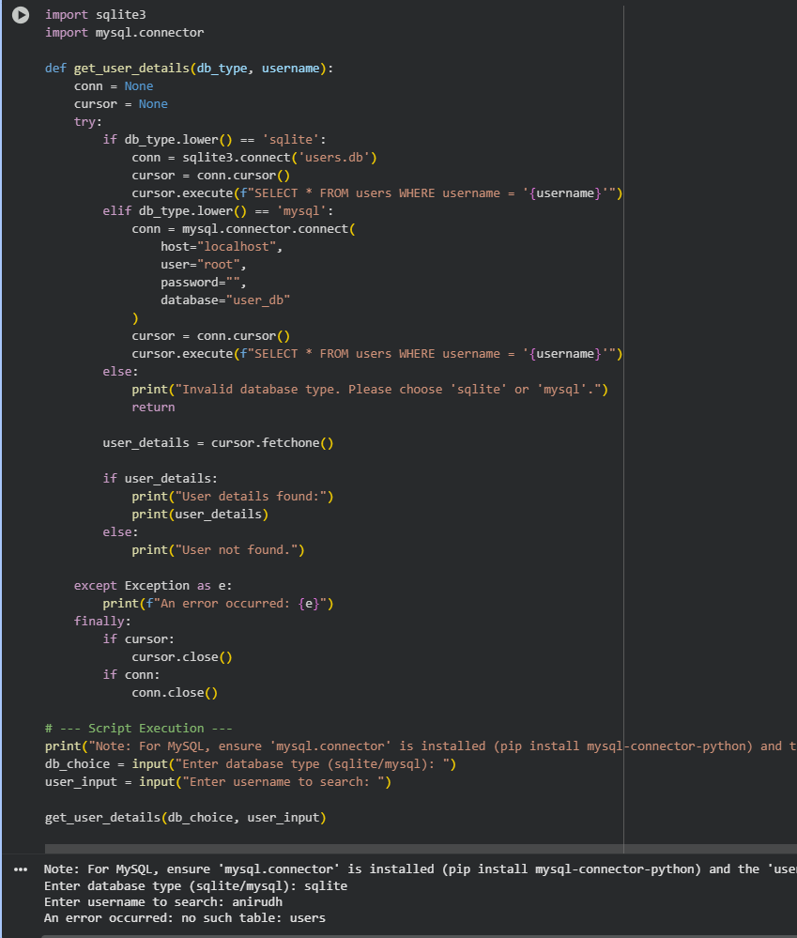
Observation: In this code we can see that the code is generated by the AI and we can see that the code is importing the mysql and sqllite into the code to run the sql in the python language without any errors .

Task 3 – Cross-Site Scripting (XSS) Check
Task:
Evaluate an AI-generated HTML form with JavaScript for XSS
vulnerabilities.
Instructions:
• Ask AI to generate a feedback form with JavaScript-based output.
• Test whether untrusted inputs are directly rendered without
escaping.
• Implement secure measures (e.g., escaping HTML entities, using
CSP).
Expected Output:
• A secure form that prevents XSS attacks

Code and Output:
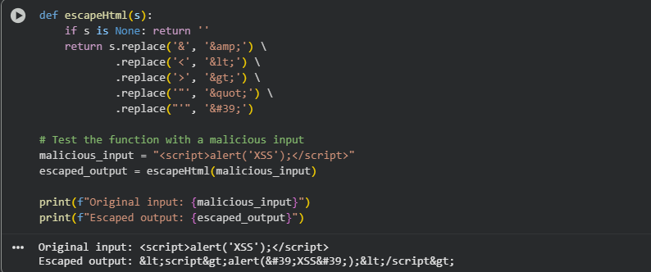
Observation : In this code we can see that the code is generated by the AI this the last part of the code as we can see that the the input is one thing and output is another thing

Task 4 – Real-Time Application: Security Audit of AI-Generated
Code
Scenario:
Students pick an AI-generated project snippet (e.g., login form, API
integration, or file upload).
Instructions:
• Perform a security audit to detect possible vulnerabilities.
• Prompt AI to suggest secure coding practices to fix issues.
• Compare insecure vs secure versions side by side.
Expected Output:
• A security-audited code snippet with documented vulnerabilities
and fixes
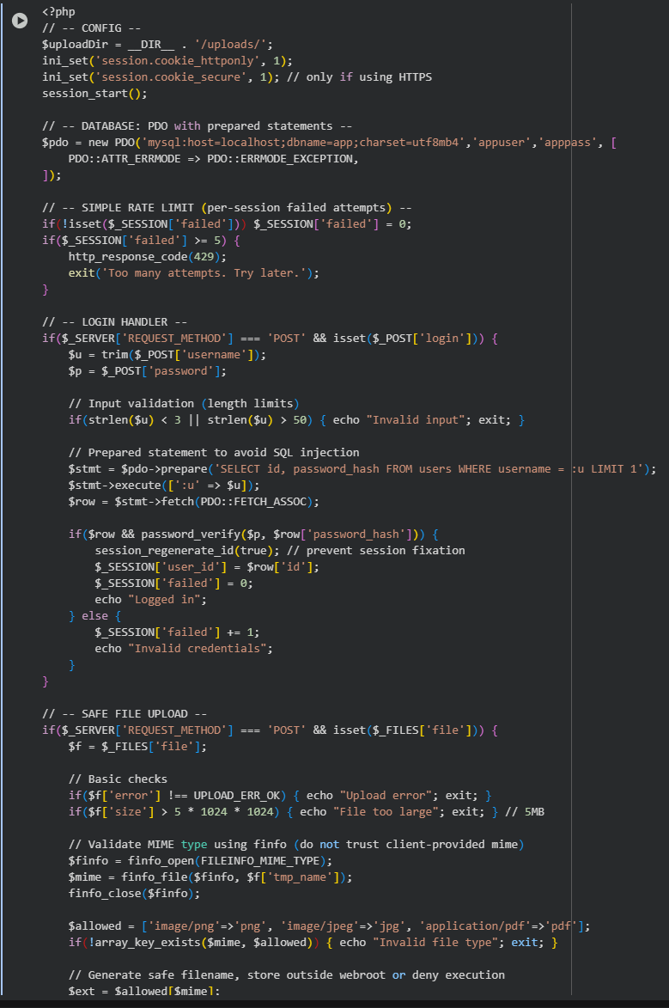
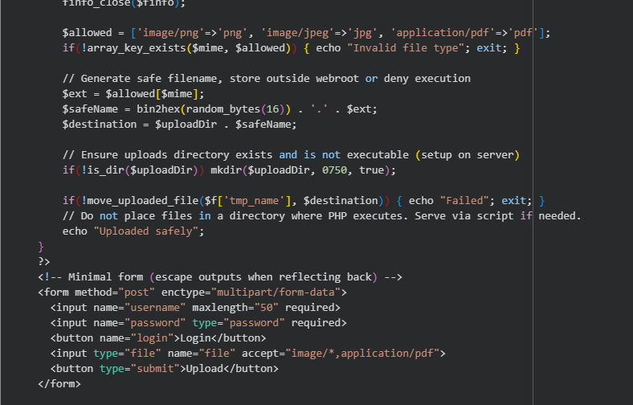
Observation: In this question we can observe that the code is generated by the Ai and then we can see that the secure code is generated by the AI to save the Data .

